**FUZZY LOGIC BASED DESTINATION PREDICTION**

**(TRAVEL BEHAVIOUR IDENTIFICATION)**

### A PROJECT REPORT

Submitted in partial fulfillment for the award of the degree of

**B.TECH**

***in***

**Information Technology**

***by***

**NISHANTH.A - 14BIT0230**

**MOHIT RAJ - 14BIT0245**

**SUBRAT MANGAL - 14BIT0255**

**Under the Guidance of**

**Prof. Prabhavathy.P**



## School of Information Technology & Engineering (SITE)

May 2017

**DECLARATION BY THE CANDIDATE**

We hereby declare that the project report entitled **“FUZZY LOGIC BASED DESTINATION PREDICTION (TRAVEL BEHAVIOUR IDENTIFICATION)”** submitted by us to Vellore Institute of Technology University, Vellore in partial fulfillment of the requirement for the award of the degree of **B.Tech.(Information Technology)** is a record of bonafide project work carried out by us under the guidance of **Prof. Prabhavathy.P**. We further declare that the work reported in this project has not been submitted and will not be submitted, either in part or in full, for the award of any other degree or diploma in this institute or any other institute or university.

Place: Vellore Signature of the Candidate

Date: Nishanth.A

Mohit Raj

Subrat Mangal

## C:\Users\Admin\Desktop\VIT - LOGO\VIT Colour logo full.jpg

## School of Information Technology & Engineering [SITE]

###### CERTIFICATE

This is to certify that the project report entitled **“FUZZY LOGIC BASED DESTINATION PREDICTION (TRAVEL BEHAVIOUR IDENTIFICATION)”** submitted by **Nishanth.A (14BIT0230), Mohit Raj(14BIT0245) & Subrat Mangal(14BIT0255)** to Vellore Institute of Technology University, Vellore in partial fulfillment of the requirement for the award of the degree of **B.Tech.(Information Technology)** is a record of bonafide work carried out by them under my guidance. The project fulfills the requirements as per the regulations of this Institute and in my opinion meets the necessary standards for submission. The contents of this report have not been submitted and will not be submitted either in part or in full, for the award of any other degree or diploma in this institute or any other institute or university.

**Prof. Prabhavathy.P**

**SUPERVISOR Associate Professor, SITE**

The Project Report is satisfactory / unsatisfactory

**Name & Signature of the Examiners**

**ACKNOWLEDGEMENT**

We would like to express our greatest gratitude to the people who have helped and supported our project. We are indebted to our Chancellor **Dr**.**G.Viswanathan,** Vice Chancellor **Dr.Anand Samuel,** Pro-Vice Chancellor **Dr**. **S. Narayanan,** Dean - SITE- **Dr. Aswani Kumar Ch**., HoD (B-Tech IT) – **Dr. M. Dinakaran**, Year Coordinator – **Prof.P.G.Shynu**, for providing me with the opportunity. We’d like to thank our guide **Prof. Prabhavathy.P** for her continuous support for our project from initial advice and contacts in the early stages of conceptual design and through ongoing advice and encouragement to this day. We also extend my heartfelt thanks to our Panelist **Prof. Ramkumar.T** for lending a helpful hand whenever necessary.

We thank all our friends who helped us in completing the project by exchanging their interesting ideas, through and for making this project easy and accurate.

**TABLE OF CONTENTS**

|  |  |  |
| --- | --- | --- |
| Chapter No | Contents | Page No |
|  | SYNOPSIS | I |
|  | LIST OF FIGURES | II |
|  | LIST OF TABLES | III |
|  | LIST OF ACRONYMS | IV |
| 1 | Introduction | 1 |
| 1.1 | Background | 3 |
| 1.2 | Problem Statement | 3 |
| 1.3 | Importance | 4 |
| 1.4 | Organization of Report | 4 |
| 2 | Overview and Planning | 5 |
| 2.1 | Proposed System Overview | 6 |
| 2.2 | Challenges | 6 |
| 2.3 | Assumptions | 7 |
| 2.4 | Architecture Specifications | 7 |
| 2.5 | Hardware Requirements | 8 |
| 2.6 | Software Requirements | 8 |
| 2.7 | Project Schedule (Gantt chart) | 9 |
| 2.8 | Work Breakdown Structure | 10 |
| 3 | Literature Survey and Review | 11 |
| 3.1 | Literature Survey | 11 |
| 3.2 | Literature Summary | 15 |
| 4 | System Design | 17 |
| 4.1 | High-Level Design | 19 |
| 4.2 | Low-Level Design | 21 |
| 4.3 | Test Cases Generation | 24 |
| 5 | System Implementation | 25 |
| 5.1 | Code and/or Architecture Development | 28 |
| 5.2 | Unit Testing | 28 |
| 5.3 | Integration Testing | 29 |
| 5.4 | Test Results | 30 |
| 6 | Results and Discussion | 31 |
| 6.1 | Output/Results | 32 |
| 6.2 | Results Analysis | 32 |
| 6.3 | Discussion | 33 |
| 7 | Conclusion and Future Work | 33 |
| 7.1 | Conclusion | 34 |
| 7.2 | Scope of Future Work | 34 |
| 8 | References | 34 |

**LIST OF TABLES**

**Table No Title Page No**

2.5.1 Hardware requirements 7

2.6.1 Software requirements 8

3.2.1 Modes of transport 12

5.4.1 Test results 24

**LIST OF FIGURES**

**Figure No Title Page No.**

Fig 2.4.1 Three tier architecture 6

Fig 2.7.1 Schedule chart 9

Fig 2.8.1 Wok break down structure 10

Fig 4.1.1 High level design 13

Fig 4.2.1 State chart diafgram 14

Fig 6.1.1 Output screenshots 25

**INTRODUCTION**

Travel and change of place impart new vigor to the mind. It gives people a sense of freedom and relaxation and adds to their adventures and experiences. Although it may seem more adventurous for a few travelers to explore a new city on their own but sometimes it becomes tedious for new travelers to look for places to visit in an unknown city and they end up going to the wrong places and wasting their time and money. To make this task easier, we have implemented an application which will provide the user with an all day tour plan. The user will be required to enter the details, like the number of travelers, their age and their interests and preferences and according to the type of tourism that the user is interested it, a full day plan will be provided by the application with places to visit and eat. This is going to help the user save time and energy in the most efficient way. In this project we have chosen the city as Bangalore and all the places of the city have been stored in the database and the application will interactively make a full day itinerary for the user according to his/her preferences. Using the details provided by the user, the application is going to filter out all the places that are recommendable for the tour group and create a day’s tour plan for the user. The aim behind this project is to achieve to most suitable tour plan for the user by using fuzzy logic technique.

* 1. **Background**

Individual travel behavior has been important in transportation research and traffic planning for decades. More recently, active travel has also become a focus for public health. Studies of adults and children have shown that individuals who walk or bike for transportation, or use public transportation, accumulate more physical activity and are more likely to meet public health recommendations. In some countries active travel has been related to obesity. These relationships, however, have been poorly studied because they are reliant on self-report data, which provide crude metrics (e.g., number of days vs. total minutes of active travel). The premise of active living research is that built environment can support more routine physical activity behaviors, and that if active travel is an equal choice compared to car travel, more people are likely to take advantage. Improvement in measurement of active travel will enable intervention studies trying to promote routine daily behaviors such as active travel.

Traditionally, travel behavior has been measured by travel and time use diaries or self-report surveys. Not only are these burdensome to participants, but also recall of events is often inaccurate and potentially biased.

* 1. **Problem Statement**

Missed flights, mosquito bites and lost luggage. We've all encountered some kind of holiday problem before. Whether it’s a bad hotel, a lost passport or an severe sunburn. And that’s why we are in dire need of help which can save us from all these problems. Guess what, our project helps you in predicting the places you can visit based on your requests.

Our aim is to create a software or application that will help its user plan a single day personalized trip to a given city. The personalization will be done using various parameters about both the people who are going on the trip and the available destinations. We’ll call the people going on the trip users and the destinations as Point of Interests (PoIs). The user will give out a details about him such as age, personality type and hobbies while signing up. S/he will fill in other trip specific details such as religious sentiments associated with the trip, category of trip (with friends with relatives or couple) and in city travel means (speed of travel) amongst others. The places available in the city will have their own set of characteristics such as Category (restaurant, temple, park, and museum), time of opening and suitable with respect to age group. We’ll call these details provided about the user and places parameters.

* 1. **Importance**

There are situations where we don’t plan a trip but wanted a break so badly and end up in a totally wrong place. A decision has to be taken carefully and our project helps in suggesting you the perfect place which you won’t regret later. And so, a system like ours comes in handy at those times thus proves its importance.

* 1. **Organization of Report**

The main body of the report is preceded by detailed contents including lists of figures, tables, and annexes followed by units used in the report. This is followed by executive summary giving briefly the scope and objectives of the study, importance of the topic, methodology, limitations, major observations / findings, and recommendations & action plan.

Chapter 1 explains the importance of the topic, background of the project and problem statement.  
Chapter 2 discusses the planning and an overview of the system. The literature survey and summary are presented in Chapter 3.

In chapter 4, the design and test cases generation, is the focus.   
Chapter 5 discusses the system implementation, testing and its results.  
Chapter 6 gives the outputs, results analysis and discussion on the result.

Chapter 7 gives the conclusions, recommendations & action plan.

All chapters are preceded by a brief synopsis of the chapter, and key words. References which have been used for certain inputs are listed after the key words. Wherever these references have been quoted / data or technical specifications taken in the text, these have been cross-referred by their serial number (appearing as superscripts in the report) in the list of References.

**2. OVERVIEW AND PLANNING**

**2.1 Proposed System Overview**

The proposed system, a “Travel behavior identification using fuzzy logic” is a online service which can run on any operation system provided with a browser.

The idea is to develop a system which identifies the user’s travel behavior and to suggest him a place which he can visit next. Each module will have specific importance. And any authorized user will be able to work on it from any place as it’s an online system. This application will cover only the places which exist in the database. This application will provide user to work on same but larger in size application where all the modules will reside together. This application is going to be the heart of tour prediction systems.

**2.2 Challenges**

* The algorithm might produce inappropriate results after reaching a large data set.
* Users can give bad feedback while adding places.
* The system won’t produce any results if there are no places in the database.
* Users may get frustrated if their experience is bad even after getting suggestions from the website.

**2.3 Assumptions**

We assume that the user isn’t taking any foreign trips because the temperature differs greatly while compared to our nation, and our system takes into account for only our local temperature.

Also assume that the signed up user is trust worthy and we take his contributions towards the website and we display it, use it for recommending to other people.

**2.4 Architecture Specifications**

We will implement the 3-tier architecture. The tiers will be as shown in the diagram. The functionality of each of the tiers is as follows:

* 1. Client tier: Is responsible for the presentation of data, receiving user events and controlling the user interface. The actual business logic (e.g. calculating total cost and tax) has been moved to an application-server.
  2. Application Server tier: Business-objects that implement the business rules "live" here, and are available to the client-tier. This tier protects the data from direct access by the clients. Our object oriented analysis "OOA" will be aimed at the development of this layer.
  3. Data Server tier: This tier is responsible for data storage. It is important to note that boundaries between tiers are logical. As shown in the deployment diagram above, the Data tier and the Application Server tier will reside on the same machine.

This architecture enables us to achieve the required Quality Attributes as follows:

* 1. Performance and Cost: The decoupling of the clients from the application server enables us to use high performance machine for only the application server, the clients can be thin clients. Thus reducing the overall cost. Since the data server and application server reside on the same machine, it would be possible to tune the data server and the application programs to achieve the desired performance, network overload is avoided. Dynamic load balancing can be done, i.e., if bottlenecks in terms of performance occur, the server process can be moved to other servers at runtime.
  2. Flexibility: Since we have a different client-tier, clients can be thin clients, or full-fledged clients running any of the operating systems. It is easily possible to increase the number of terminals as required by the manager.
  3. Security: The security features can be implemented at the application server layer. Security is bolstered by the decoupling of the application server and the clients. As a rule servers are "trusted" systems. Their authorization is simpler than that of thousands of "untrusted" client-PCs. Data protection and security is simpler to obtain. Therefore it makes sense to run critical business processes, that work with security sensitive data, on the server.
  4. Modifiability: Re-definition of the storage strategy won’t influence the clients. RDBMS’ offer a certain independence from storage details for the clients. In the future, even radical changes, like let’s say switching form an RDBMS to an OODBS (may be for performance reasons), won’t influence the client. In well designed systems, the client still accesses data over a stable and well designed interface which encapsulates all the storage details. The application server can be built using the OOD paradigm and can provide for the incremental changes. Also addition and deletion of patches from the application server can be done on the fly without affecting any of the clients.

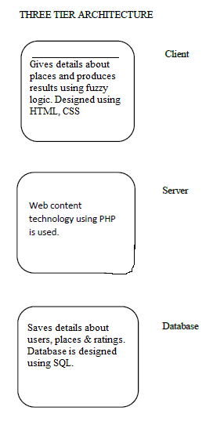

Fig 2.4.1 Three tier architecture

**2.5 Hardware Requirements**

|  |  |  |
| --- | --- | --- |
| **Component** | **Minimum** | **Recommended** |
| Processor | 2.5 gigahertz (GHz) | Dual processors that are each 3 GHz or faster |
| RAM | 1 gigabyte (GB) | 2 GB |
| Disk | NTFS file system–formatted partition with a minimum of 3 GB of free space | NTFS file system–formatted partition with 3 GB of free space plus adequate free space for your Web sites |
| Drive | DVD drive | DVD drive or the source copied to a local or network-accessible drive |
| Display | 1024 × 768 | 1024 × 768 or higher resolution monitor |
| Network | 56 kilobits per second (Kbps) connection between client computers and server | 56 Kbps or faster connection between client computers and server |

Table 2.5.1 Hardware requirements

**2.6 Software Requirements**

|  |  |
| --- | --- |
| **Component** | **Recommended** |
| Front end | Html, Css |
| Back end | Php, MySQL 5.5, Wamp server |
| OS | Windows 7 or higher |
| IDE | Netbeans |

Table 2.6.1 Software requirements

**2.7 Project Schedule (Gantt chart)**

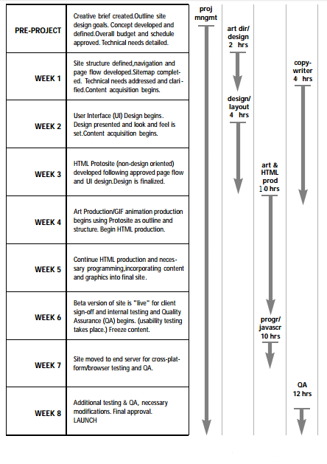

Fig 2.7.1 Schedule chart

**2.8 Work Breakdown Structure**

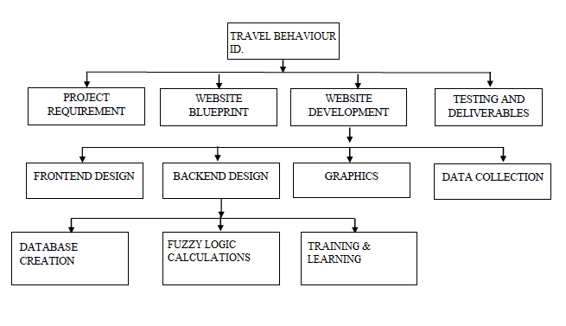

Fig 2.8.1 Work break down structure

**3. LITERATURE SURVEY AND REVIEW**

**3.1 Literature Survey**

**Title :** Does Nationality, Gender and Age affect travel motivation? A case of visitors                  to the Caribbean Island of Barbados.

**Author** : Cristina Jo¨nsson

                Dwayne Devonish

**Year** : 2008

**Description:**

The central element of the tourism system is the destination with its features and resources. It is therefore vital to empirically examine tourist motivation in order to try to identify markets in which tourist motivations match the destination (Kozak, 2002).‘‘Push’’ and ‘‘pull’’ factors and the importance in shaping tourist motivations ere emphasized in Crompton’s (1979) study. Most authors accept this model highlighted by Crompton. ‘‘Push’’ factors are intangible factors that pushes a tourist away from home, while ‘‘pull’’ factors are tangible characteristics pulling tourists towards the destination, referring to what makes a destination attractive for potential visitors’ including historical and cultural resources, beaches, and accommodation (Andreu, Bigne´, & Cooper, 2000). These factors are relevant in the current study, as they provide a framework for understanding tourist motivations.

Other studies (e.g., Dann, 1977;Kozak, 2002) have relied on this framework(push and pull factors), and have been discussed below in order to provide the background on which this study is based. Various approaches have been suggested in the pursuit of understanding tourist motivations. Dann (1977), for example, used survey data on visitors’ attitudes towards Barbados to identify two basic motivations: anomie and ego-enhancement. Both of these proposed tourist motivations were seen by the author as ‘‘push’’ factors (i.e., internal factors predisposing the individual to travel such as the desire for rest and relaxation, adventure, escape, and health). Anomie, according to Dann (1977), represented the desire to transcend the feeling of isolation inherent in everyday life and to simply ‘‘get away from it all.’’ This is supported by Krippendorf (1987) who posits that relaxation and escape motivations are the two most important psychological drives that people experience before decisions of taking an overseas vacation are developed. Within this context people travel primarily to satisfy their social needs. These needs include mixing with other fellow tourists, the need to meet local people, and spend time with people they care about. Ego-enhancement, on the other hand, derived from the need for recognition, which is obtained through the status conferred by travel. This is the need to satisfy personality needs by, for example, visiting places they never visited before. The study concluded that by focusing on ‘‘push ‘factors, the problem of motivation is easier tackled. It also showed that anomie and ego enhancement both had a strong fantasy component.

**3.2 Literature Summary**

Tour guides must address multiple stake holders simultaneously. Visitors expect that their safety and health will take a high priority, but at the same time expect an enjoyable and rewarding travel experience. Some have special needs and expectations associated with their particular cultural background, their physical and intellectual capabilities, and their passions and interests in particular subject matters (Weiler and Ham, 2002). Employers expect the guide to provide high-quality service to visitors in order to meet these expectations, as well as to manage the group, the itinerary and other logistical aspects of the experience to maximize not only visitor satisfaction but also profit margins (Cohen, 1985: Pond, 1993).

Tour guides face challenges both from within and from their operating context. Guides may have personal limitations of skills, competences, etc. Externally, they must also subscribe to rules and regulations of their areas of operations, their employers and their clients. The guides are often pressed for time, caught between their obligation to please their employers and the tourists, and subject to government regulations (Dahles, 2002; Dritsas, 2006).

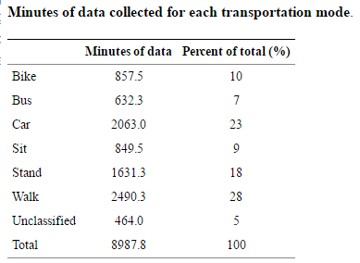

Table 3.2.1 Modes of transport

**4. SYSTEM DESIGN**

**4.1 High-Level Design**

The software construction for the I-15 system will be built on a three-tier architecture to provide a separation of the client, business objects, and data store.  This separation is enabled by the use of well-defined interfaces between the tiers.  This type of architecture is the key enabler of the "Thin" client architecture.  In this architecture the Client Tier is responsible for data collection and data presentation but does not control the business rules or data storage.  A library of service utilities that provide communication, logging and other cross tier services supports the Three-Tier architecture.

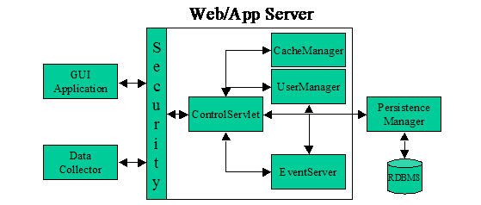

Fig 4.1.1 High level design

**4.2 Low-Level Design**

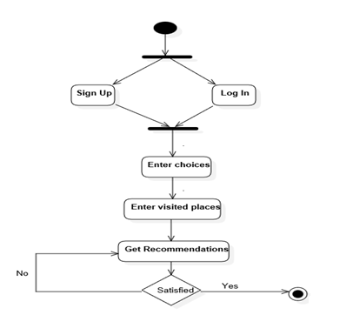

Fig 4.2.1 State chart diagram

* 1. **SYSTEM IMPLEMENTATION**

**5.1 Code and/or Architecture Development**

<html>

<head><link rel="stylesheet" type="text/css" href="stylesheet.css"></head>

<body class="back" style="text-align: center;">

<?php

$n=$_POST['name'];

$a=$_POST['age'];

$adv=$_POST['adventure'];

$mon=$_POST['month'];

$fn=$_POST['fun'];

$flag=0;

if ($_SERVER["REQUEST_METHOD"] == "POST") {

}

include ("connection.php");

$agefac=0;

if($a<=18)

$agefac=5;

else if ($a > 18 && $a < 30) {

$agefac = 4;

} else if ($a >= 30 && $a < 50) {

$agefac = 3;

} else if ($a >= 50) {

$agefac = 2;

}

$domadv=1;

$domfn=1;

$age_influence=0.125;

echo "<h1>"."Thank you $n!"."</h1>"."<br>";

//predicted fuzzy score

$ifs=$agefac+$fn+$adv; // crisp value

//echo"<br>"."$ifs a $agefac b $adv ala $fn"."<br>";

$defuzzyfactor=4;

$im=mysql_query("select* from places") or die(mysql_error());

while($rambo=mysql_fetch_array($im)){ // predicted place can be found

$moh=$rambo['rate'];

if($ifs==$moh){

$age_influence=0.2;

$defuzzyfactor=5;

}

}

if($agefac==5 || $agefac==4) // for people who are able to have more fun and are more energetic

{

if($adv>$fn) // here the adventure factor dominates over the fun factor

{

$domadv=0.2;

$domfn=0.125;

}

if($fn>$adv) // here the fun factor dominates over the adventure factor

{

$domfn=0.2;

$domadv=0.125;

}

if($adv==$fn) //here both the factors are equally dominating

{

$domadv=0.2;

$domfn=0.2;

}

}

else

if($agefac==3 || $agefac==2) // for people who are NOT that much able to have more fun and are more energetic

{

if($adv>$fn) // here the Religious factor dominates over the NOn Adventerous (boring sober pale straight forward) factor

{

$domadv=0.125;

$domfn=0.2;

}

if($fn>$adv) // here Non Adventurous (Boring sober) factor dominates over REligious Factor {

{ $domfn=0.125;

$domadv=0.2;

}

if($adv==$fn) //here both the factors are equally dominating

{

$domadv=0.2;

$domfn=0.2;

}

}

$iage=$agefac* $age_influence;

$iadv=$adv* $domadv;

$ifn=$fn* $domfn;

$pfn=$iage+$iadv+$ifn;

//fuzzy score

$fscore=$pfn/3;

//echo "<br>"."$ifs"."<br>";

//defuzzified

$df=$pfn*$defuzzyfactor;

$fs=round($df);

echo"<br>"."";

echo "<h1>"."Your fuzzy score = $fscore month is $mon"."</h1>"."<br>";

echo"<br>"."The age_factor is- $agefac the corresponding Degree of Association is $iage"."<br>";

echo"<br>"."The adventure_factor is- $adv the corresponding Degree of Association is $iadv"."<br>";

echo"<br>"."The fun_factor is- $fn the corresponding Degree of Association is $ifn"."<br>";

echo"<br>"."The Defuzzy value is= $fs"."<br>";

if($mon==1) // winter can go

{

$em= mysql_query("select * from places where winter=1 ORDER BY rate DESC") or die(mysql_error());

while($result = mysql_fetch_array($em)){

$p=$result['placename'];

$r=$result['rate'];

if($r==$fs)

{echo"$p <br>";

$flag=1;

}}

echo"<br>"."$flag";

if($flag==0){

echo"<br>"."exact place not found but near by rated places are-"."<br>";

$no=mysql_query("select * from places where winter=1 and rate<'$fs' ORDER BY rate") or die(mysql_error());

while($resultlow=mysql_fetch_array($no))

{ $rlow=$resultlow['rate'];}

echo"$rlow"."<br>";

$low=mysql_query("select * from places where winter=1 and rate='$rlow'") or die(mysql_error());

while($finallow=mysql_fetch_array($low)){

$lowp=$finallow['placename'];

echo"$lowp"."!<br>";}

$no2=mysql_query("select * from places where winter=1 and rate>'$fs' ORDER BY rate DESC") or die(mysql_error());

while($resulthigh=mysql_fetch_array($no2))

{ $rhigh=$resulthigh['rate'];}

echo"<br>"."$rhigh"."<br>";

$high=mysql_query("select * from places where winter=1 and rate='$rhigh'") or die(mysql_error());

while($finalhigh=mysql_fetch_array($high)){

$lowp=$finalhigh['placename'];

echo"$lowp "."!<br>";}

} }

else if($mon==2) // summer can go

{

$em= mysql_query("select * from places where summer=1 ORDER BY rate DESC") or die(mysql_error());

while($result = mysql_fetch_array($em)){

$p=$result['placename'];

$r=$result['rate'];

if($r==$fs)

{echo"$p";

$flag=1;

}}

echo"<br>"."$flag";

if($flag==0){

echo"<br>"."exact place not found but near by rated places are-"."<br>";

$no=mysql_query("select * from places where summer=1 and rate<'$fs' ORDER BY rate") or die(mysql_error());

while($resultlow=mysql_fetch_array($no))

{ $rlow=$resultlow['rate'];}

echo"$rlow"."<br>";

$low=mysql_query("select * from places where summer=1 and rate='$rlow'") or die(mysql_error());

while($finallow=mysql_fetch_array($low)){

$lowp=$finallow['placename'];

echo"$lowp"."!<br>";}

$no2=mysql_query("select * from places where summer=1 and rate>'$fs' ORDER BY rate DESC") or die(mysql_error());

while($resulthigh=mysql_fetch_array($no2))

{ $rhigh=$resulthigh['rate'];}

echo"<br>"."$rhigh"."<br>";

$high=mysql_query("select * from places where summer=1 and rate='$rhigh'") or die(mysql_error());

while($finalhigh=mysql_fetch_array($high)){

$lowp=$finalhigh['placename'];

echo"$lowp"."!<br>";}

} }

else if($mon==3) // rainy can go

{

$em= mysql_query("select * from places where rainy=1 ORDER BY rate DESC") or die(mysql_error());

while($result = mysql_fetch_array($em)){

$p=$result['placename'];

$r=$result['rate'];

if($r==$fs)

{echo"$p";

$flag=1;

}}

echo"<br>"."$flag";

if($flag==0){

echo"<br>"."exact place not found but near by rated places are-"."<br>";

$no=mysql_query("select * from places where rainy=1 and rate<'$fs' ORDER BY rate") or die(mysql_error());

while($resultlow=mysql_fetch_array($no))

{ $rlow=$resultlow['rate'];}

echo"$rlow"."<br>";

$low=mysql_query("select * from places where rainy=1 and rate='$rlow'") or die(mysql_error());

while($finallow=mysql_fetch_array($low)){

$lowp=$finallow['placename'];

echo"$lowp"."!<br>";}

$no2=mysql_query("select * from places where rainy=1 and rate>'$fs' ORDER BY rate DESC") or die(mysql_error());

while($resulthigh=mysql_fetch_array($no2))

{ $rhigh=$resulthigh['rate'];}

echo"<br>"."$rhigh"."<br>";

$high=mysql_query("select * from places where rainy=1 and rate='$rhigh'") or die(mysql_error());

while($finalhigh=mysql_fetch_array($high)){

$lowp=$finalhigh['placename'];

echo"$lowp"."!<br>";}

} }

?>

</body>

</html>

**5.2 Unit Testing**

Unit testing is a software development process in which the smallest testable parts of an application, called units, are individually and independently scrutinized for proper operation. Unit testing can be done manually but is often automated.

In our application there are several modules which had undergone unit testing. For example,

Sign Up/ Login module: Different string were provided in the form to check whether it is doing the validation perfectly or not. Name cannot have numeric or special symbols.

Add module: Places can be added to the database by the user. Same places with different ratings have been provided by different users to check the rate handling part of the project.

Evaluate module: The main functionality of the project is to predict the place to be visited next. Real time users tried the website and their feedback is taken for correctness checking.

**5.3 Integration Testing**

Integration testing (sometimes called integration and testing, abbreviated I&T) is the phase in software testing in which individual software modules are combined and tested as a group. It occurs after unit testing and before validation testing.

**5.4 Test Results**

|  |  |  |  |  |  |  |
| --- | --- | --- | --- | --- | --- | --- |
| Test Case ID | Test Case Description | Input Data | Expected Result | Actual Result | Pass/Fail | Remarks |
| 1 | evaluation | fs=10 | 10 | 9 | P | - |
| 2 | evaluation | fs=7 | 7 | 7 | P | - |

**6. RESULTS AND DISCUSSION**

**6.1 Output/Results**

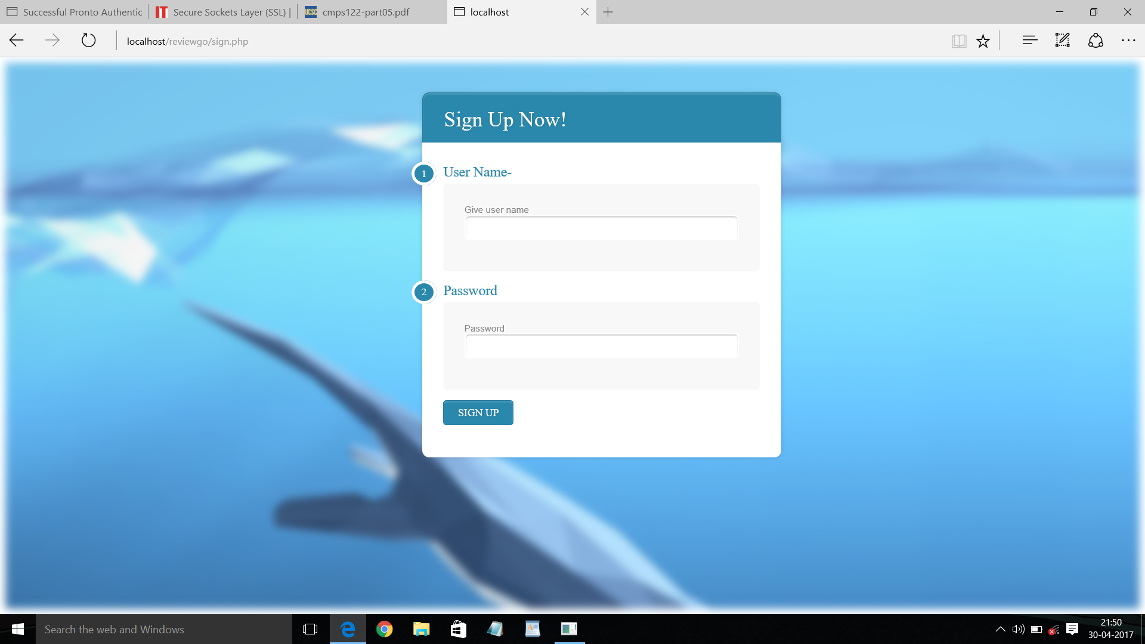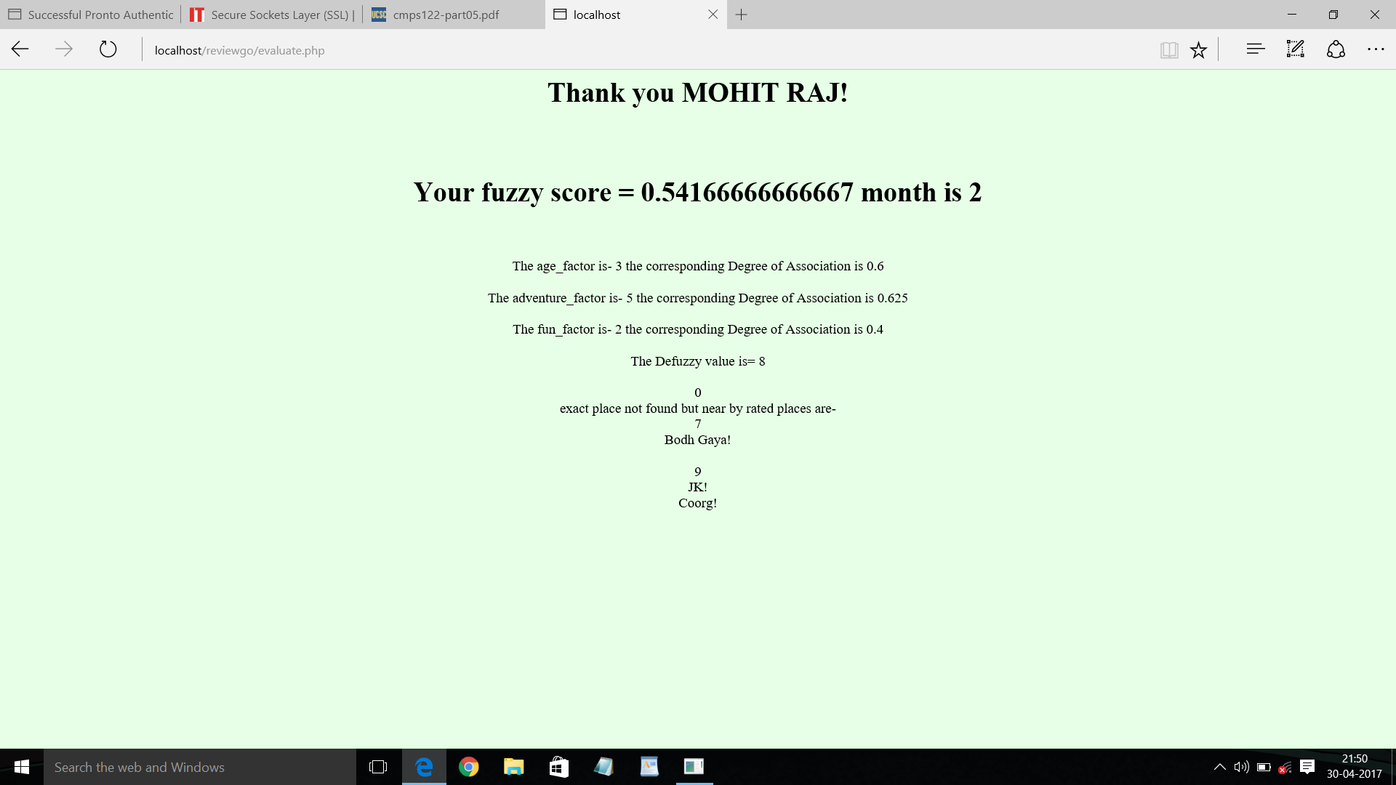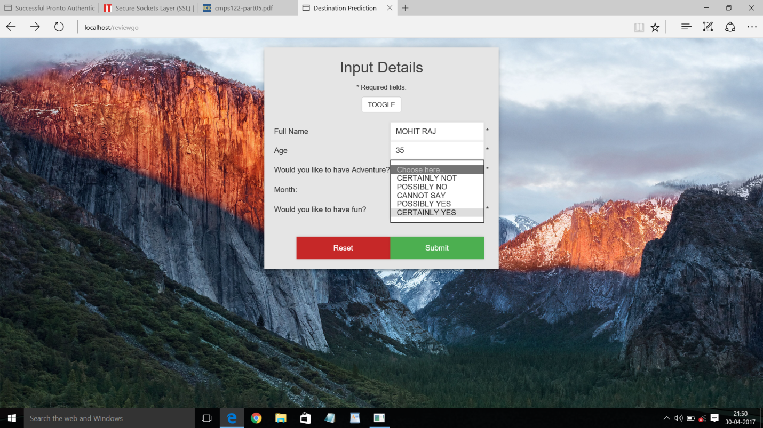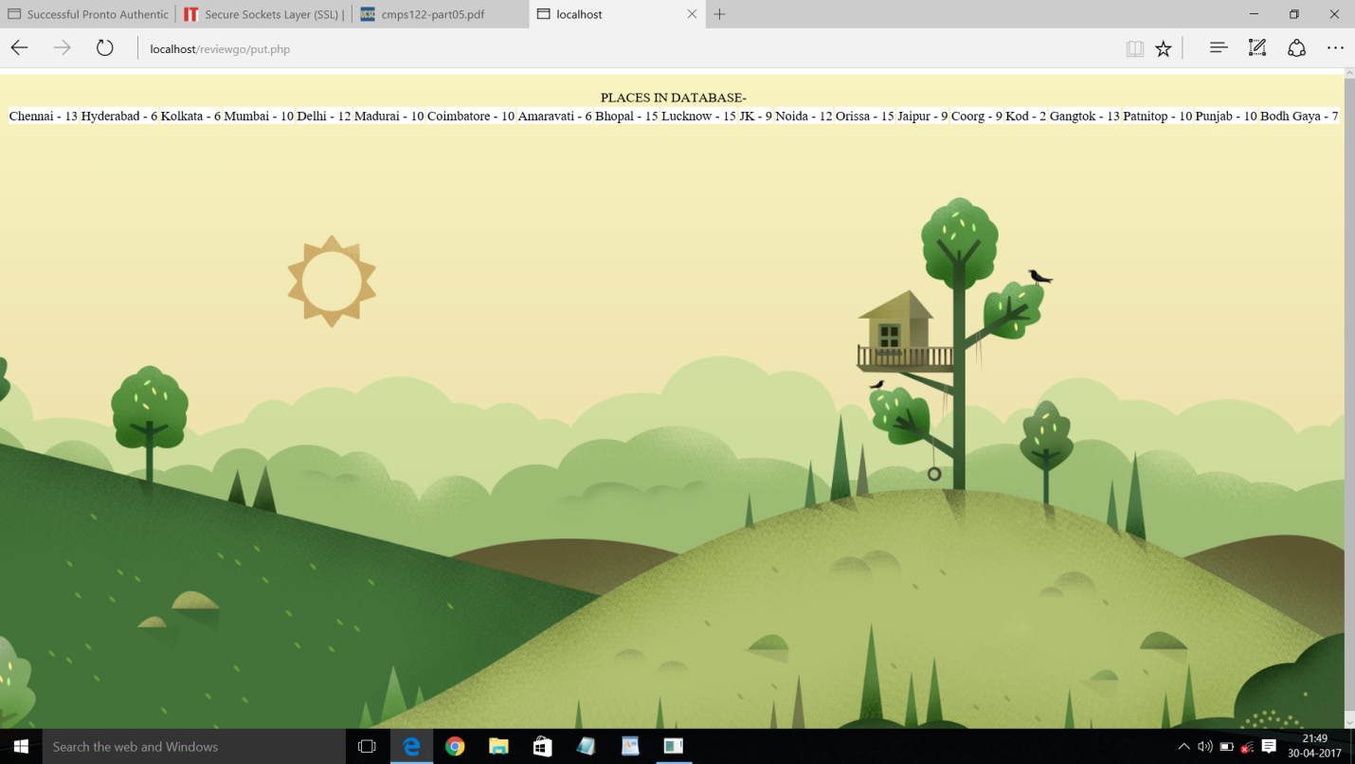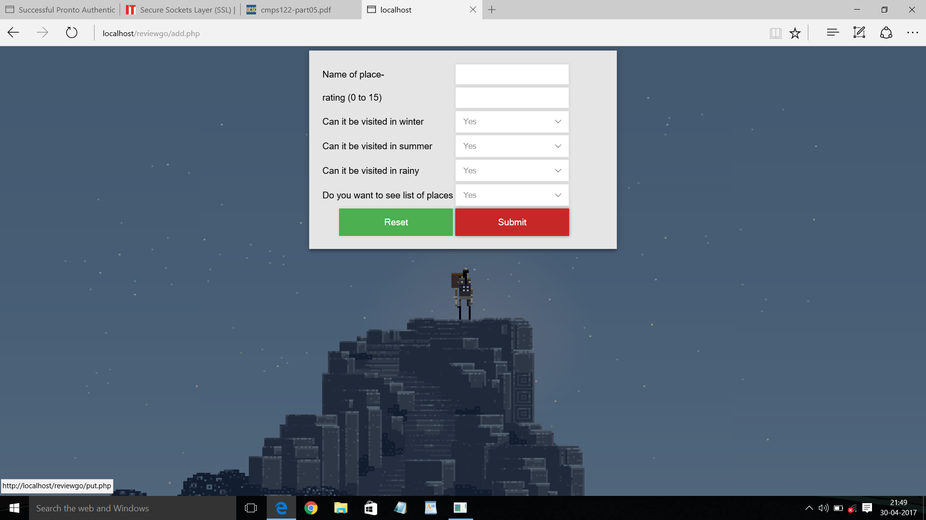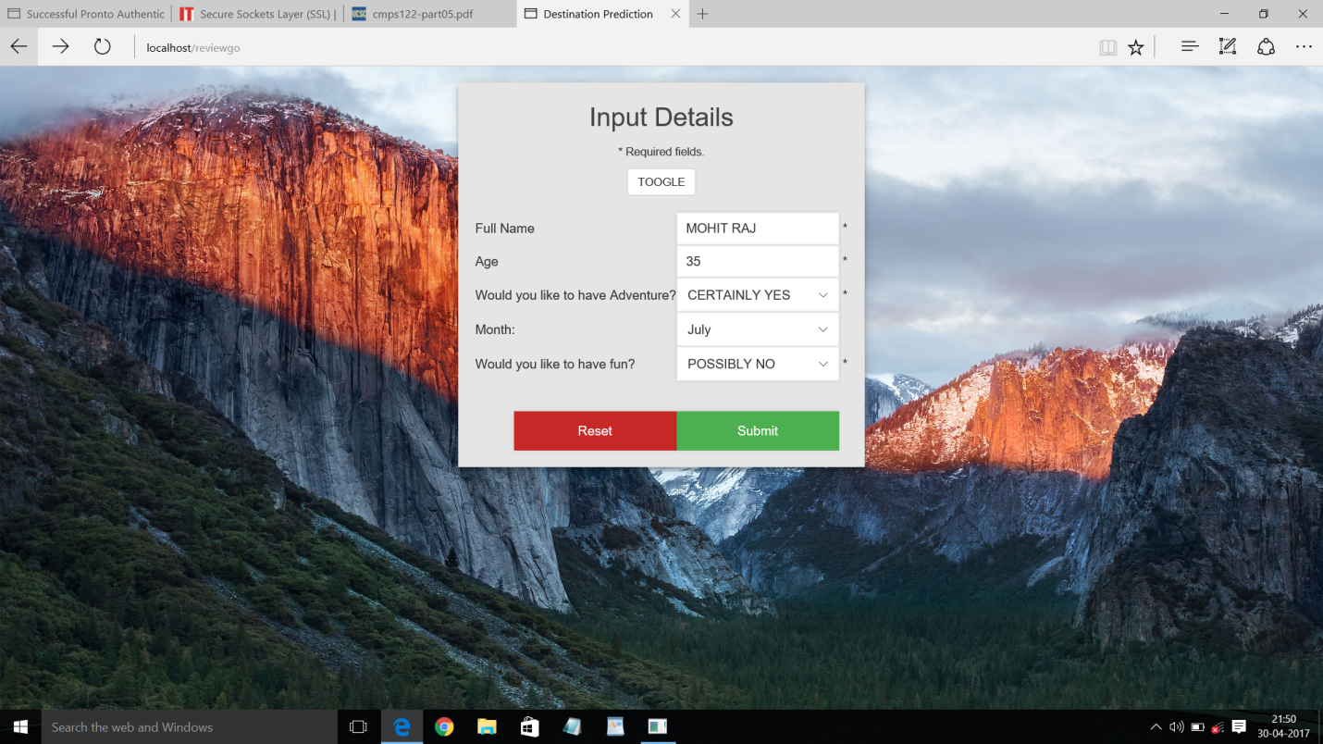

**7. CONCLUSION AND FUTURE WORK**

**7.1 Conclusion**

This project is one with humongous potential for development into a commercial application. It also acts as an illustration for application of multiple concepts of Artificial Intelligence and Soft Computing at one place. The purpose of this project is however very clear. It is to solve a basic problem faced by us travelers all the time; to select places to visit from a wide array of interesting places in a city. It makes sure all the places are properly rated on multiple parameters according to the kind of attraction they are. It takes into account several factors such as age, time a person has and so on to provide the best possible experience to the user. It has also been designed in a way such that any number of factors can also be incorporated into it later on, one of which is machine learning and which can make this project a self-learning customizable application. The ideal application or product which can be envisioned keeping this project in mind can end up helping millions.

**7.2 Scope of Future Work**

* Any tourist agency can make use of it for saving customer details in database.
* Tourism group can use it for managing their location, hotel, vehicles details.
* This application can easily implemented under various situations.
* We can add new features as and when we require.
* Reusability of this application is also possible.

**8. REFERENCE**

Aggrawal A (2012) Application of fuzzy Logic Model Trip M. tech thesis NIT Trichi

Zade L.A. (1965) Origin Destination Matrix with Fuzzy weights IAC Vol.338